Spectroscope
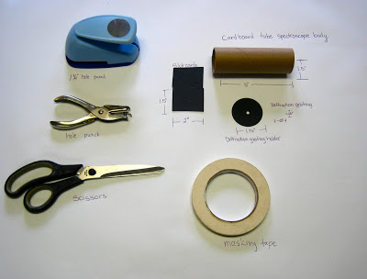

Materials:
•1.5’’ dia. cardboard tubes (we got ours from www.uline.com : S-5816, 1.5’’x36’’ kraft mailing tubes, but aluminum foil tubes would work just as well)
•Black card stock
•Diffraction grating (we got ours from www.rainbowsymphonystore.com : item #10503, 6x12’’ 1000 lines/mm $25 for ten sheets, www.sceintificsonline.com item # sku 3052116-GRP, $9 for two 6x12’’ 254000 lines/inch
•Masking tape

Tools:
•Scissors
•Hot glue gun
•Hole punch (or punches)

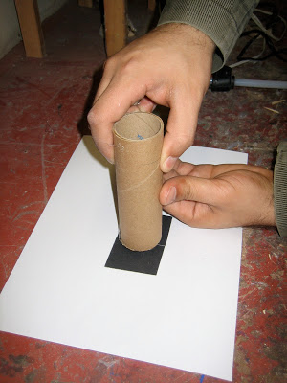

Cut the large cardboard tubes down to a 5-6’’ length using a fine-toothed wood saw (faster) or a box cutter (slower but potentially more accurate). It is not important that the tubes be cut squarely but it is important that they be cut evenly so there will be no unwanted light leaks when the cardstock ends are glued on.

Cut two approx. 1.5x2’’ pieces of cardstock making sure that the long edges are straight, these pieces will make your slot. Place you pieces down on a flat surface with 2 of the straight edges together leaving them a little less then a mm gap between them. Apply glue to one end of the tube and place it on the two card pieces with the gap in the center of the tube.

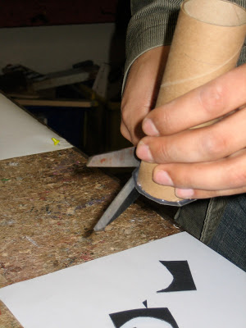

After the glue sets trim off the excess card stock to prevent it from getting ripped off in the future.

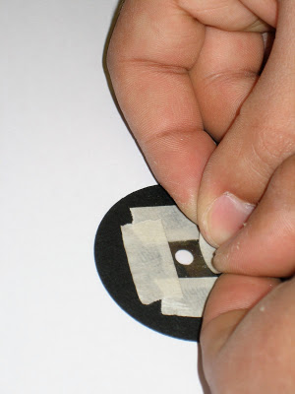
Cut out a circle that is bigger than the diameter of your tube, we used a big 1.75’’punch from Michael’s to speed things up though it’s not necessary. Then use a standard hole punch to make a hole as close as you can to the middle of the cardstock circle. Place a .25x.25’’ square of diffraction grating over the hole and tape it down with masking tape.

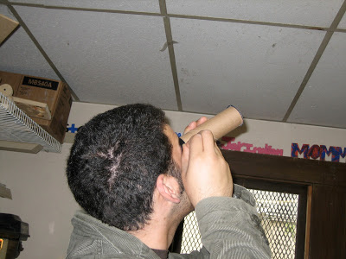

Next, align the slot to the diffraction grating by pointing the slot end (oriented vertically) of the spectroscope tube at a light source and place the cardstock circle with diffraction grating on the other end and slowly rotate it. Look through the diffraction grating at the side of the tube (not out the end), when the diffraction grating is aligned properly bands of colors should appear parallel to the slot off to the right or left, not a single line above or below the slot. This may take a little while the first time around as the colors appear further from the center of the tube than most people expect, but once you find them it becomes very intuitive. Once you’ve got the scope well aligned either glue around the edge while holding the circle in place. Alternatively, put a tick mark on the tube and circle and then glue the tube onto the circle using the mark as a guide.

Things to do and notice:
As spectroscopes are meant to analyze light, it’s a good idea to have a number of different light sources for students to look at prepared. Incandescents provide fairly full spectrum light though it’s a bit red shifted. LEDs can create monochromatic light or compound colors depending on if they use their chemistry or their lens to color the light. Compact fluorescents are particularly interesting to look at as they almost always have incomplete visual spectrums creating strong banding. Colored light filter’s subtractive effect can be demonstrated as they will block most colors dissimilar from their appearance. Sun light (full spectrum light) can be analyzed simply looking at a brightly lit area outside, though you should never look directly at the sun as the spectroscope does not provide adequate protection for this to be safe. In all cases, the component colors can be related to the chemistry of the elements being excited and producing light. Fluorescents use a combination of mercury vapor and a phosphorus coating to make various varieties of white light. LEDs use various combinations of semi conductors metals to produce a wide selection of colors, and unlikely things like pickles can even be made to glow a characteristic yellow orange when electricity is passed through them due to their sodium content. The glowing pickle color is similar to streetlights as they are sodium vapor lamps.

